**Object Oriented Programming**

**WWS 37 - PROJECT INSPECTION**

**DATE: 24th february 2022**

Inspector Team

1 3

2 6

3 9

4 5

5 1

6 8

7 2

8 4

9 7

Modularity /10 packages 7:47-7:52

Clean code /10 variables, vertical/horizontal, CamelCase, nouns, verbs, comments 7:57-8:07

MVC /10 View (no code, calling to functions), Controller/Utils (functions), Model (no BR methods, only attributes POJO) 8:10 - 8:20

One design pattern /10 Singleton, Template Method, Strategy 8:22 - 8:27

Diagrams consistency /10 Use Case -> actions (GUI), Class Diagram -> View, Model 8:27 - 8:37

Unit tests /10 assert(expected,actual) -> 100, run (error (red), green 8:37 - 8:42

GUI navigability /10 navigate to the system options 8:47-8:52

GUI fields validation /10 every TextField must be validated (-1) 8:52:-9:02

Functionality /10 3 to 4 computations, MongoDB Atlas 9:02-9:07

MongoDB /10 Data in the Cloud 9:07-9:12

______________________________

TOTAL /100

Modularity

Clean code

MVC

One design pattern

Diagrams consistency

Unit tests

GUI navigability

GUI fields validation

Functionality

MongoDB

15 CRUZ PANTOJA DARLING MICAELA

Modularity 10/10

Clean code 8/10

MVC 9/10

One design pattern 0/10

Diagrams consistency 9/10

Unit tests 9/10

GUI navigability 10/10

GUI fields validation 10/10

Functionality 10/10

MongoDB 10/10

______________________________

**TOTAL 85 /100**

**Modularity:**

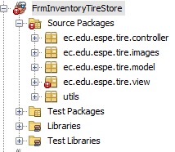 The packages are correctly distributed. THAT IS CORRECT

**Clean code:**

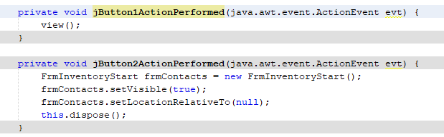 Generic names of buttons. The jButton1 must have been changed of name.

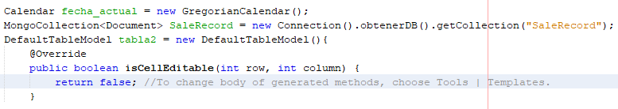

The program has commented lines, those must be deleted.

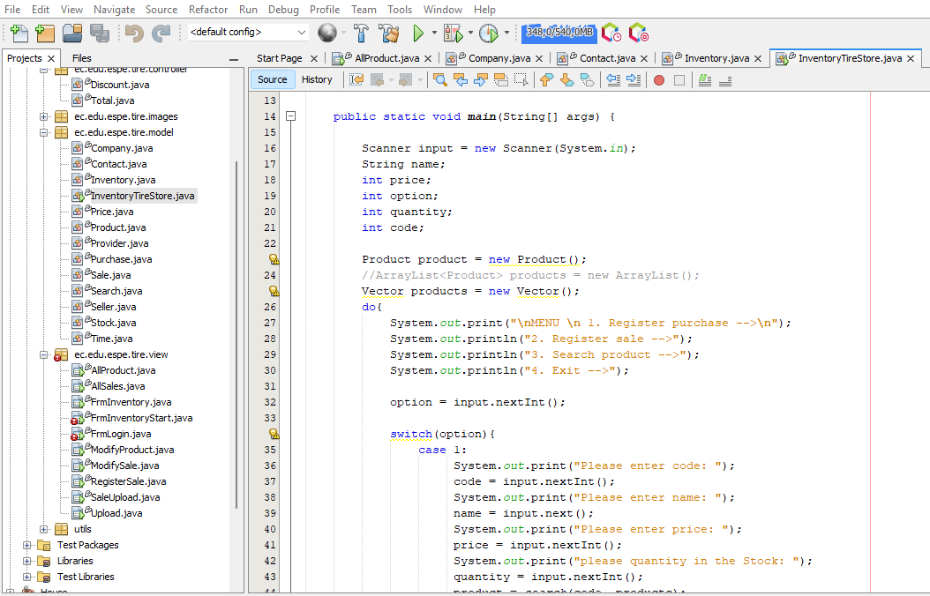

The class called Inventory Tire Store, must have just atributes, but no methods, because it belongs to the Model Package.

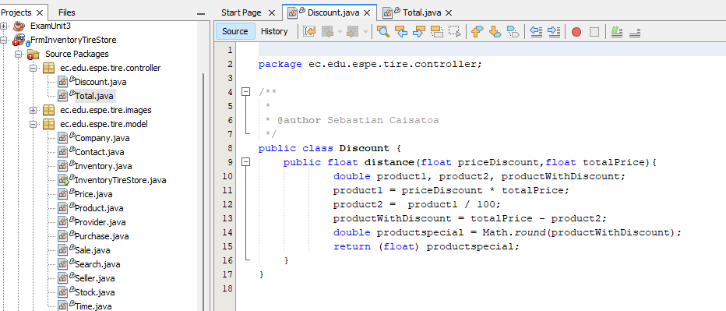

The class called Discount, has just methods, because it belongs to the Controller Package. THAT I.S CORRECT

**One design pattern:**

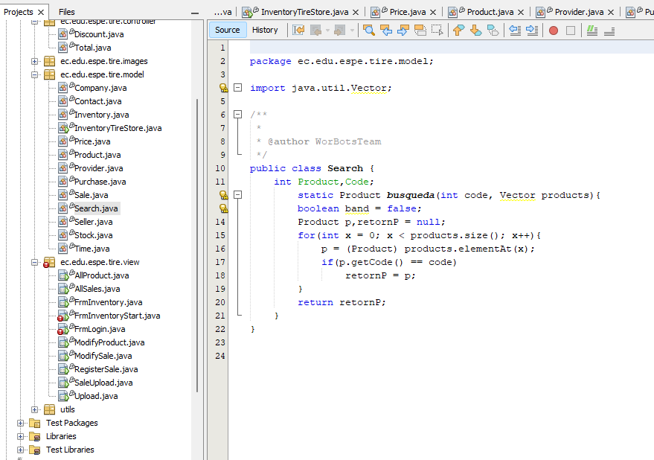

**Diagrams consistency**

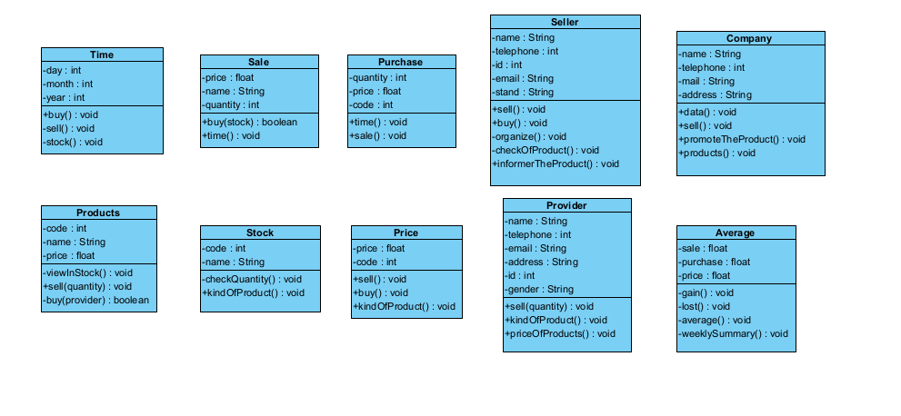

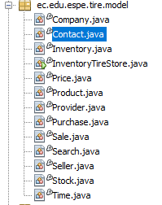

**Unit tests**

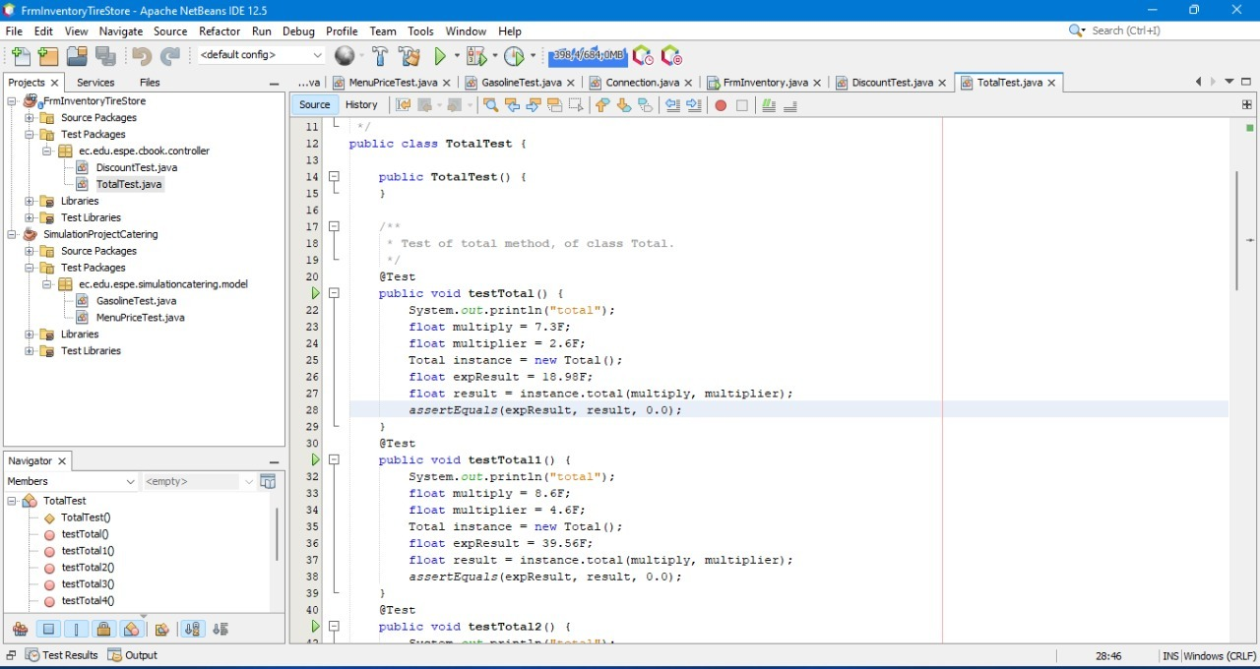

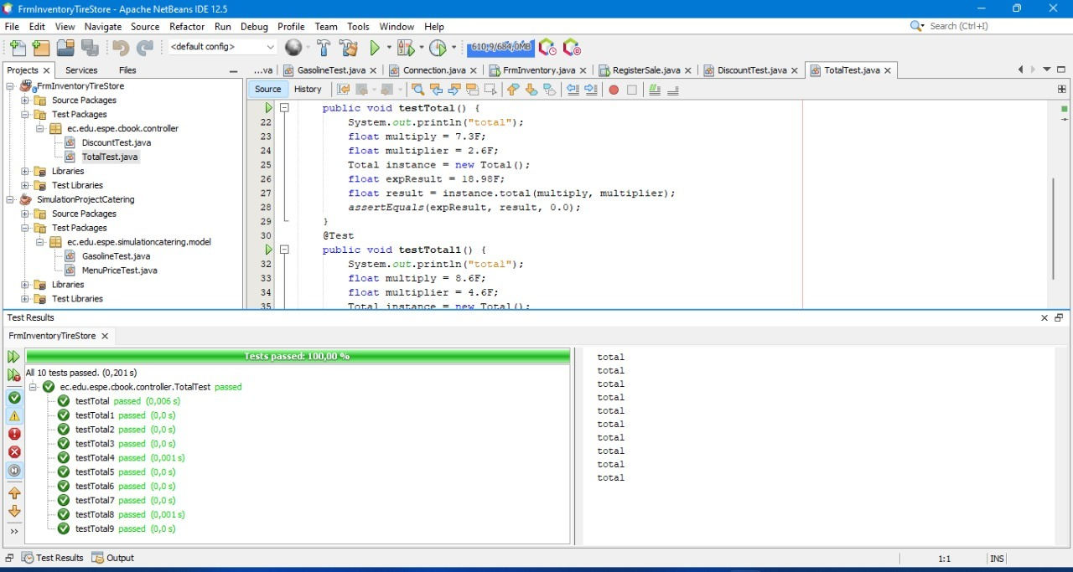

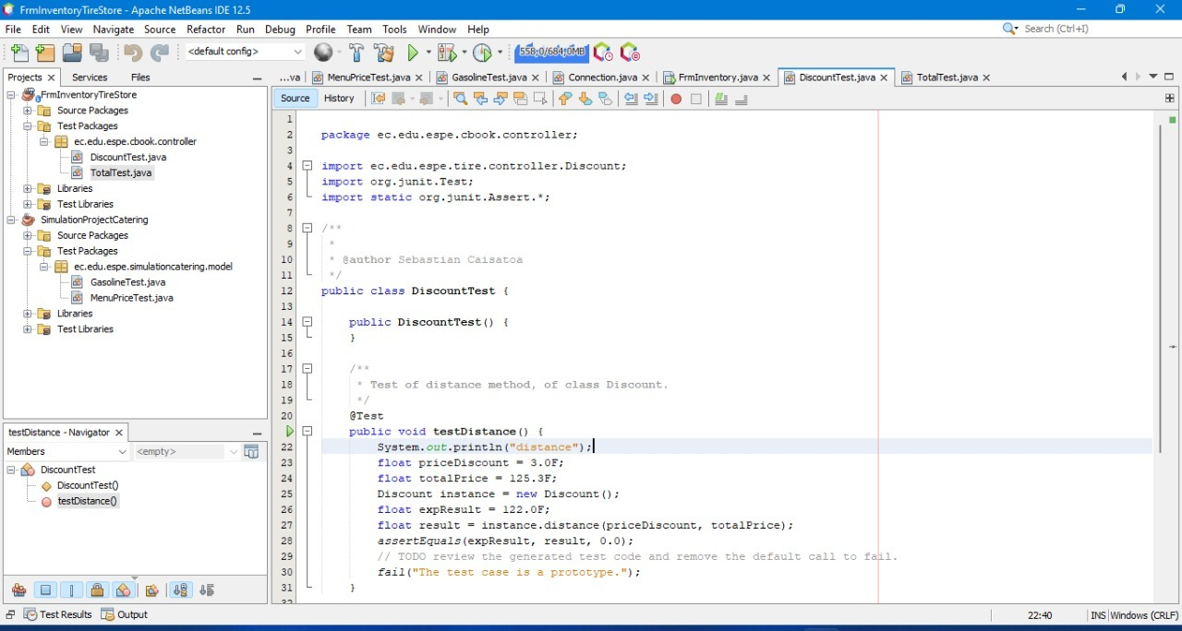

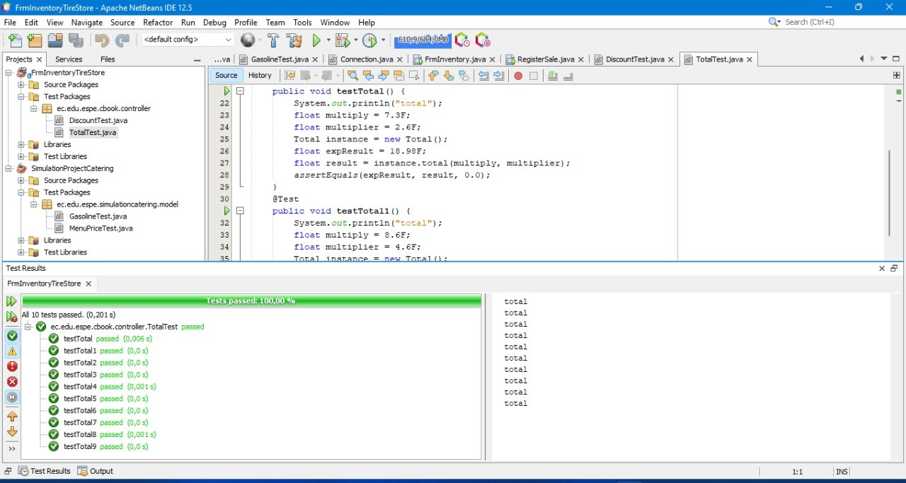

**GUI navigability:**

The video shows the navegability S/N

<https://youtu.be/lMolYcEhrMM>

**GUI fields validation:** OK

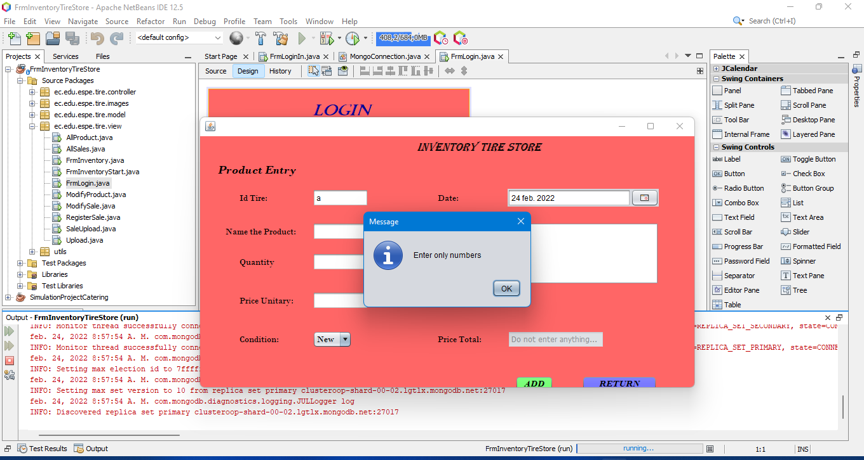

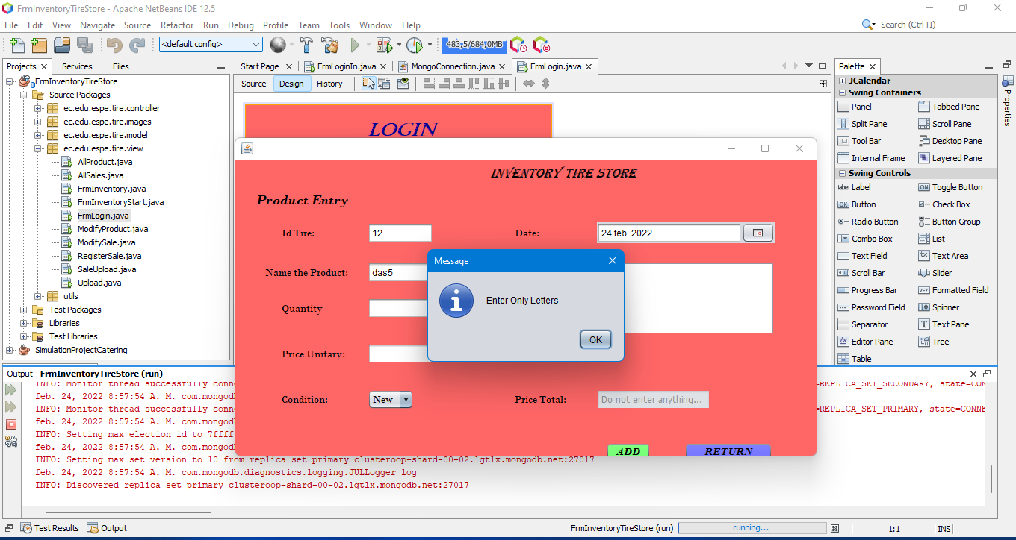

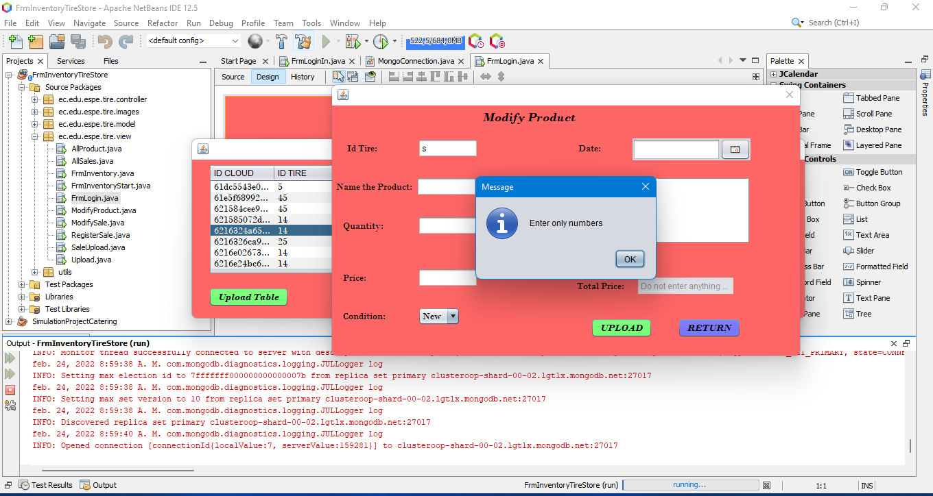

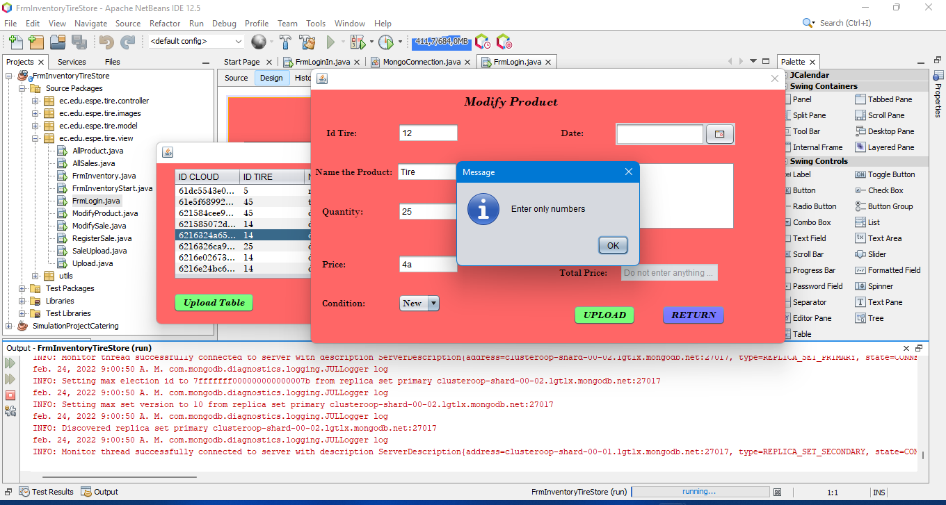

**Functionality**

It is OK

It is OK

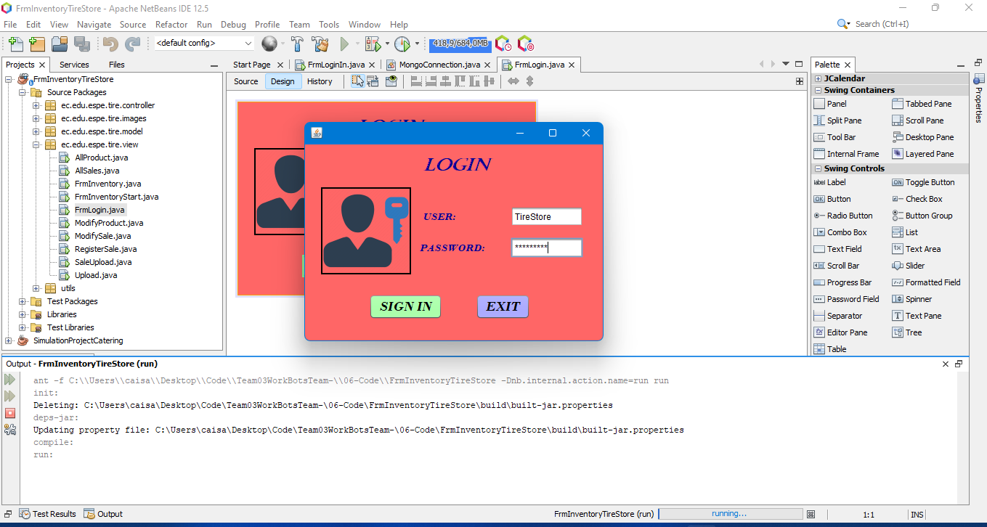

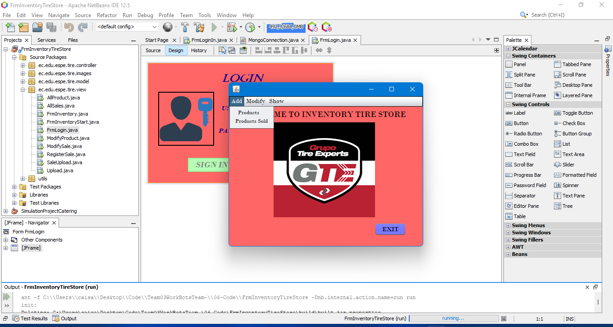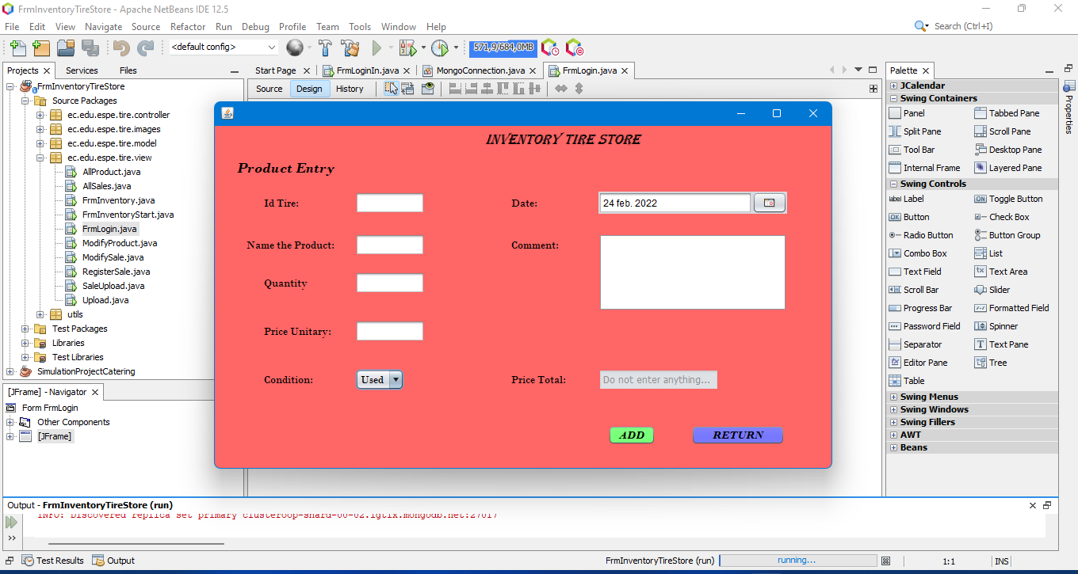

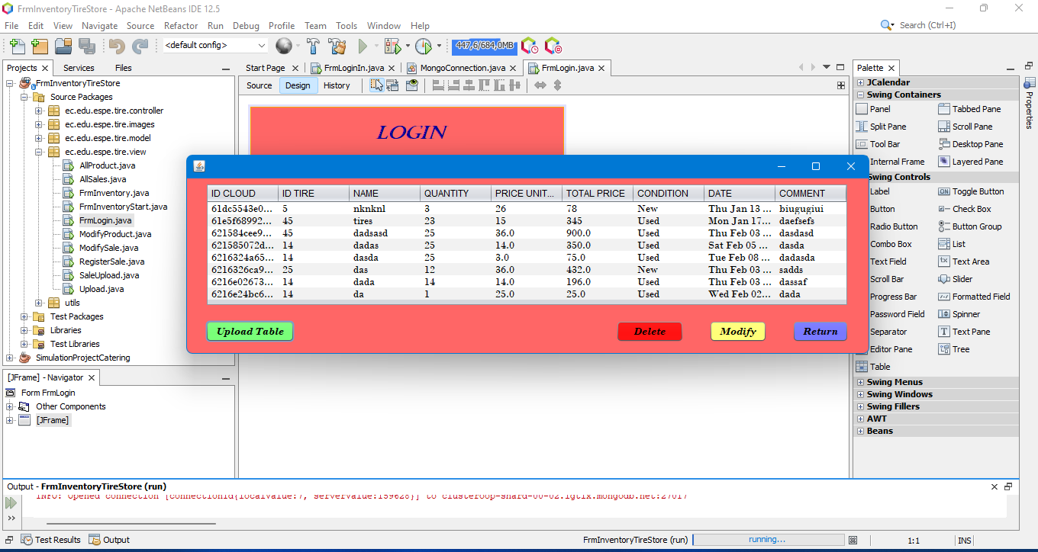

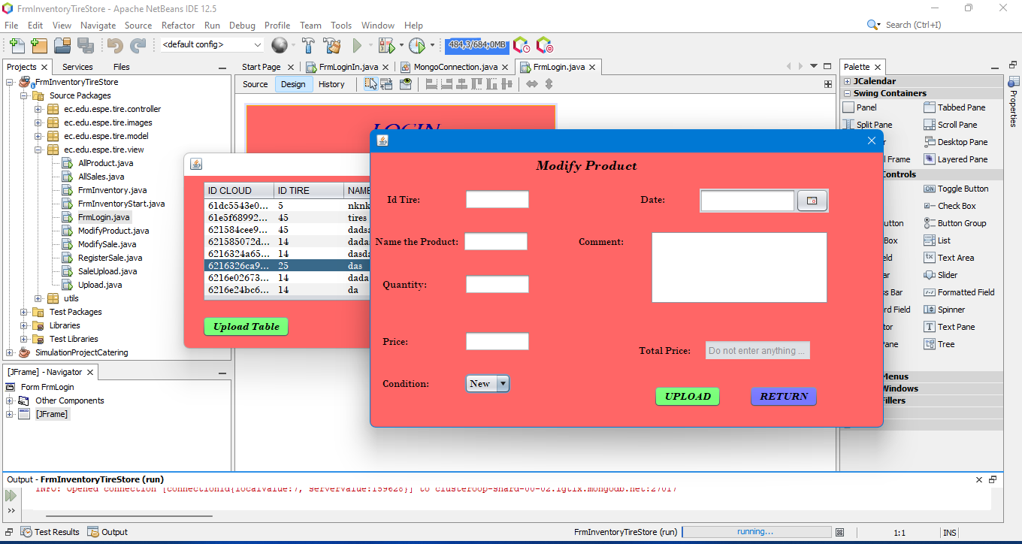

**MongoDB**

The connection with DB is OK.

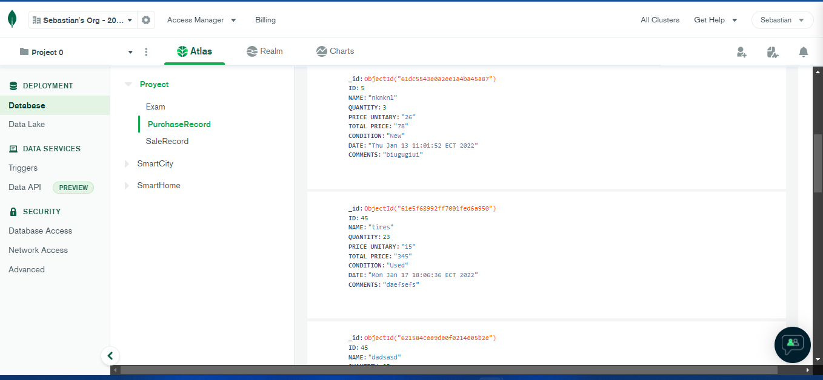

Inspector: T8 (Rocket Team) Leader: Alan Shuguli

Team: T4 (The ½ java programmer) Leader:Alejandro De la Cruz

Project: Inventaryshop3

Video: <https://www.youtube.com/watch?v=UtOXQd4pSPM>